Practicum Computational Vision

Practicum 1: Image processing toolbox in Matlab (Part IV)

# This session will practice the segmentation by kmeans and meanshift in Matlab.

**4.1 Obtain image segmentation by the kmeans algorithm**

Read the image "animales.jpg" and apply the kmeans segmentation technique as shown in Fig.1 (See the help at the end of this text). Choose the optimal k value of the function. Is the result affected by rescaling the image size augmenting it or reducing it? Is the result always the same when running several times? Why? Substitute the label of each cluster in the resulting image with the average color of the cluster.

**4.2 Adding spatial information to the kmeans segmentation (Optional):**

Add as features the spatial position of the pixels and apply the kmeans. Is the result improved and when?

**4.3 Mean-shift segmentation:**

Apply the mean shift segmentation and compare it to the kmeans. You can find the meanshift in mathworks.com. Note that the format and order of the input and output parameters change! Discuss the results - advantages and limitations. Do you need to determine the number of clusters? Is the result changing when executing the algorithm several times? Why? Implement a function to visualize the pixels of each cluster with the mean RGB value of the cluster.

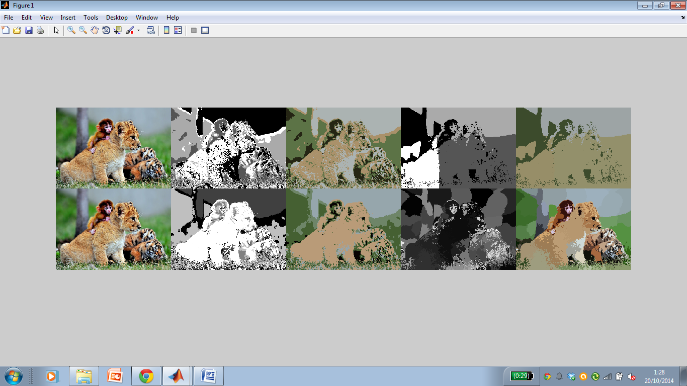

*Fig.1 Original image (left), first row: kmeans segmentation, clusters of the kmeans - 2nd image, clusters substituted with the mean rgb value - 3rd image, clusters obtained with RGB+ spatial features - 4th image, the same clusters but substituted with the mean rgb value. Second row: analogous but using mean shift segmentation.*

**4.4 Adding spatial information to the kmeans segmentation (Optional):**

Apply the mean shift segmentation adding to the RGB values the spatial position of the pixels.

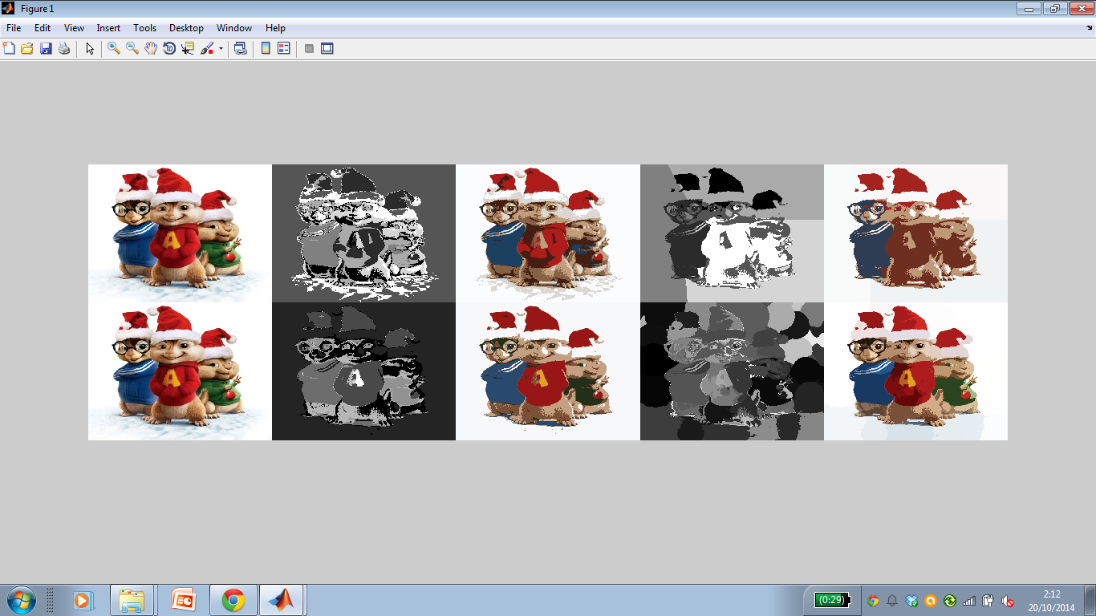

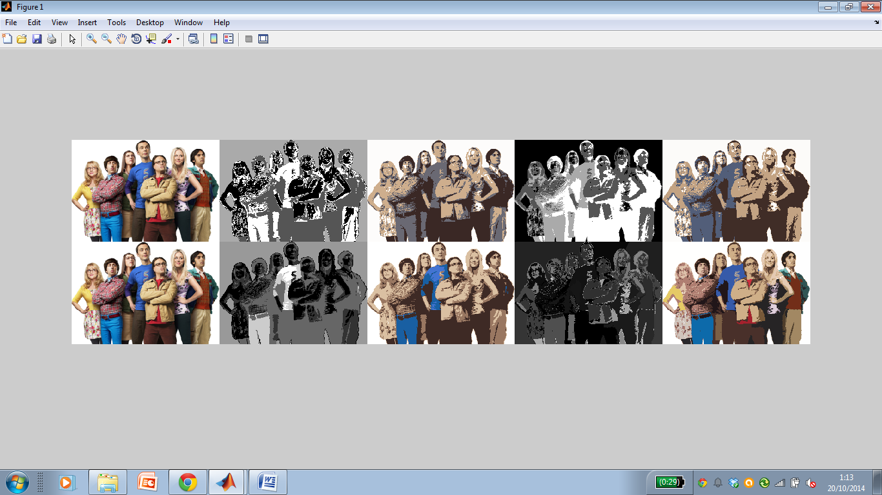

*Fig.2. Some more examples…*

Repeat the tests on a pair of other images and discuss the results.

**Help**:

function [imres] = testKMeans(im)

% this is the classical kmeans algorithm

im1d=reshape(im, size(im,1)*size(im,2),3);

% Add here the spatial coordinates ….

k=4; % cluster in 4 clusters

idx=kmeans(double(im1d),k);

im2d=reshape(idx, size(im,1),size(im,2));

im2d=((double(im2d)-min(min(im2d)))/(max(max(im2d))-min(min(im2d)))*255.0);

imres=cat(2,im,cat(3,im2d,im2d,im2d));

end

**Deadline:** November, 6, 2014, 23:50h. All 4 parts of Practicum 1 shell be delivered as a zipped file with separate functions corresponding to each exercise.